Document Id: 08_10_07_2
Date Received: 2007-08-10 Date Revised: 2008-02-13 Date Accepted: 2008-02-15
Curriculum Topic Benchmarks: M.2.3.13, M.3.3.2, M.3.3.7, M.3.3.14, M.4.4.1, M.8.3.3, M.8.3.5, M.8.4.11, S.1.3.3, S.10.3.7
Grade Level: High School [9-12]
Subject Keywords: air, soft drink, pressure, volume, gas laws
Rating: moderate

Water Bottles, Root Beer, and Air

By: Loren White, Dept. of Physics, Atmospheric Sciences, and Geoscience
Jackson State University, P. O. Box 17660, Jackson, MS 39217
e-mail: loren.d.white@jsums.edu

From: The PUMAS Collection http://pumas.jpl.nasa.gov
© 2007, California Institute of Technology. ALL RIGHTS RESERVED. Based on U.S. Gov't sponsored research.

Materials: Flexible plastic water or soft drink bottle; access to freezer or refrigerator.

Background
The common plastic water bottle makes a useful container for demonstrating properties of gases and liquids. As typical examples, we know that “air” is a gas (made up of nitrogen, oxygen, water vapor, ozone, carbon dioxide, and several “trace” gases) and water is a liquid. We should also note that gases and liquids are both “fluids”. That is, they can flow or change shape, rather than having a fixed shape like a solid.

So what happens when a water bottle is opened? Usually not much. What about with a bottle or can of shaken root beer though? In that case you’re likely to get a messy explosion! The reasons are related to the properties of gases and liquids, especially as expressed through pressure and density.

Water vs. Root Beer
The important difference between water and root beer is that the root beer is carbonated. Carbonation means that carbon dioxide gas has been dissolved into the liquid. Although water usually has some dissolved gases in it also (in particular oxygen, which fish use to breathe), the amount is only enough that small bubbles may gradually form in a bottle (or glass) of water that is left standing too long. In contrast, the carbonation in soft drinks (especially root beer) can produce a lot of bubbles, and shaking the root beer speeds up the process for releasing (“degassing” or “effervescing”) the carbon dioxide. If the bottle is sealed shut, then the released carbon dioxide increases the pressure inside the bottle, which in turn slows down the bubble formation. Once the bottle is opened though, the pressure will equalize with the surrounding atmospheric pressure. This is done by the carbon dioxide gas explosively exiting the bottle, taking with it much of the “foam” which is made up of unpopped bubbles. Although the bubbles contain carbon dioxide on the inside, their surfaces are made of the root beer liquid, resulting in the familiar mess. There are now warning labels on many carbonated drink containers because of the possibility of the lid explosively shooting into someone’s eye. For safety reasons (and to avoid a mess), it is not recommended to demonstrate a shaken soft drink explosion.

On the other hand, if the root beer is left for a couple days with no lid, then the carbonation will more gradually be lost to the air above, resulting in a “flat” tasting drink. You may also want to confirm that there is more dissolved gas in a soft drink than in water by comparing the density. Even if filled all the way to the top (which is not normally the case), a soft drink will float when put in a tub of water because of reduction of density by the dissolved carbon dioxide.

Some Properties of Gases

Effects of Temperature
Now let’s consider the behavior of a bottle of air. Seal up (tightly) a bottle full of air and put it in a freezer for 15 to 30 minutes (or a refrigerator if you’re more patient). Do you notice any differences when you take it out? Assuming that your air was reasonably warm to start with and the bottle is flexible enough, you should see that your bottle has crumpled up (Fig. 1). Why? Unlike liquids, gasses change their density substantially with temperature changes, approximately following what’s called the Ideal Gas Law (or sometimes called the Equation of State for an ideal gas). One form of this simple equation is:

pV=nRT

where p is the pressure, V is the volume, n is the “amount” of gas substance measured in moles, R is a constant value, and T is the temperature (using the “absolute” temperature in degrees Kelvin). What this equation means is that if we decrease the temperature of the gas (by putting it in a freezer), then the value of nRT will be less and so the value of pV must also be less in order to maintain the equality of the left and right sides. Of course pV can decrease by decreasing the value of either p or V (or both). Since the bottle is flexible enough to easily “crumple”, the air inside it will decrease its volume when chilled, while maintaining an inside pressure that is close to that outside.

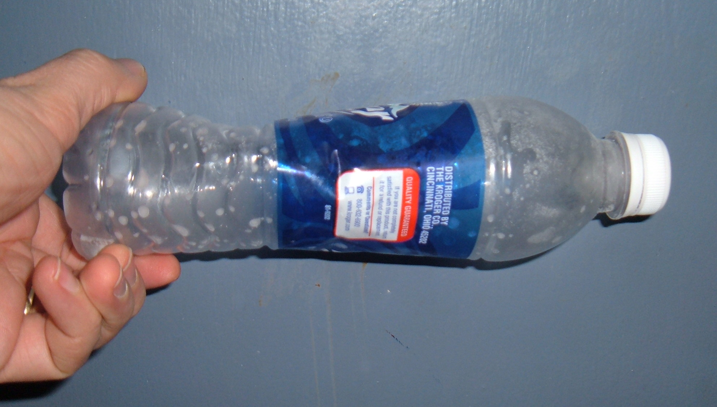

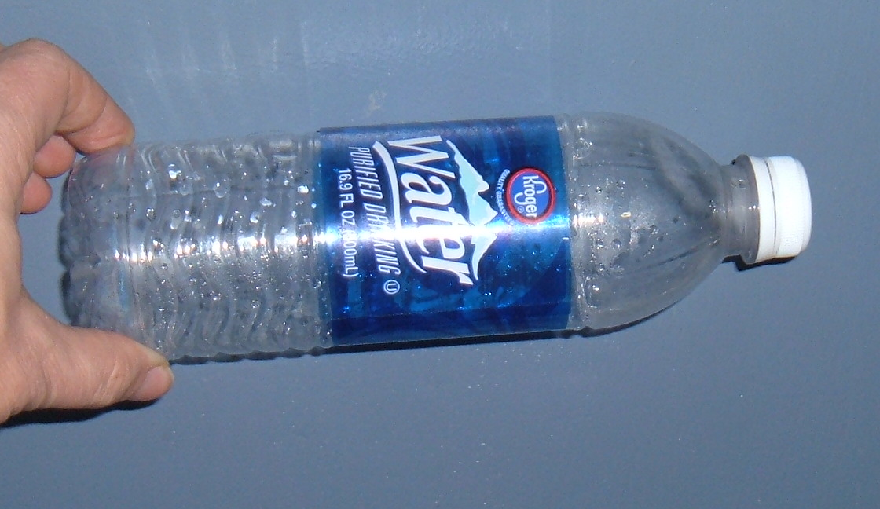

Figure 1: (a) Small water bottle a few seconds after removal from freezer; (b) Small water bottle several minutes after removal from freezer.

We can get an idea of the magnitude of change in volume due to temperature by rearranging the equation into the form

$V=\frac{\text{nR}}{p}T$.

Assume a room temperature of about 300 K (around 80°F) and a freezer temperature of 260 K (about 10°F), with n, R, and p all constant values. The ratio of 260/300 equals 0.87, indicating a 13% decrease in absolute temperature (and therefore of the right hand side of the equation). So the volume (on the left side) should also decrease by about 13%. We still have the same amount (in terms of mass or weight) of air, but it is just compressed into a smaller volume. This ability of air to compress and expand based on changes of temperature and pressure is of vital importance to understanding many of the processes in the earth’s atmosphere, from the formation of clouds to the structure of hurricanes.

Initial Temp. | Final Temp. | Final/Initial Temp. Ratio | Final/Initial Volume Ratio | Compression
300 K | 260 K | 0.87 | 0.87 | 13%

As you have probably already noticed, the bottle will rapidly expand back to it normal volume (and shape) as it warms back to the normal room temperature. You can speed this up by holding it down in a bath of hot/warm water. This speeds it up not only because of higher temperatures, but because water has a higher specific heat capacity than the air and is also a better conductor of heat.

To further investigate the relationships, we can consider some variations. Suppose that we seal a bottle up with very cold air and then warm it. What will happen? Since the bottle’s plastic is unable to expand very much from its normal shape, we’ll notice primarily a build-up of pressure inside the bottle, resulting in a “poof” of air if the cap is removed (similar to the exploding root beer, though the pressure arises for different reasons). Or we can use a bottle that is mostly filled with water. Since the water (as a liquid) does not obey the Ideal Gas Law or change density substantially (unless if it freezes into ice!), the changes observed will be only due to the small amount of air. So the crumpling effect should be less pronounced than for the air only case. You might want to measure the actual room and freezer temperatures and convert them into Kelvin for use in the Ideal Gas Law.

Effects of Pressure
Would changes of atmospheric pressure produce any effects on our bottles? We can consider three common ways that atmospheric pressure changes: 1) with altitude; 2) with changes in the weather; 3) and due to “tidal” effects.

Airline passengers may notice that the altitude effect on pressure can have a noticeable effect on water bottles. Pressure decreases quite rapidly with increasing altitude, so that airplane pilots, mountain climbers, and surveyers use the change of pressure to determine altitude with an “altimeter”. If a passenger flies from Denver, CO (at about 5000 ft above sea level; 1500 m) to Houston, TX (basically at sea level), the atmospheric pressure can be expected to change from about 850 mb (millibars) to about 1010 mb. (Millibars are the metric units most often used for pressure by weather forecasters. Other units for pressure include hectopascals (hPa; identical to millibars), inches of mercury (in Hg), and pounds per square inch (psi).) Dividing 1010/850 gives 1.19, which means that the pressure in Houston is about 19% greater than (or 1.19 times) the pressure in Denver. If everything on the right hand side of the Ideal Gas Law stays the same (in other words, the temperature is about the same), then we must have a 19% decrease in the volume V in order to maintain equality. This will result in the passenger finding a crumpled up bottle upon arrival in Houston. It will not expand back to its normal size unless it is either opened or taken back to a high altitude. (Since pressure decreases with altitude, what happens to the water bottle during the flight? Normally commercial airplane cabins are “pressurized” so that the pressure during the flight is similar to that at sea level instead of being the same as outside the plane.)

Denver Pressure | Houston Pressure | Houston/Denver  Pressure Ratio | Compression
850 mb | 1010 | 1.19 | 19%

If we can’t afford a plane ticket, is there any other way to see this pressure effect? The main advantage of the airplane flight was to provide a quick way to get between places of significantly different altitudes (so that we would not lose patience and prematurely open the bottle), as well as maintaining a relatively constant indoor temperature. In mountainous areas, large changes of altitude may be more readily accessible by other means. Would the difference in altitude (pressure) between the top and bottom of a tall building have a noticeable effect? Compare the height to the altitude difference used in the airplane example.

What about the other two factors causing atmospheric pressure changes? The difference in pressure between stormy (low pressure) areas and fair weather (high pressure) areas across the United States on a typical day is usually not more than about 40 mb. Relative to the standard sea level pressure of 1013.25 mb, this corresponds to about a 4% variation. Based on our earlier discussion, a 40 mb increase in pressure a couple days after a powerful storm system would then cause a 4% decrease in the bottle’s volume. This might be barely noticeable. A drop in pressure of the same amount should expand the volume, assuming that the bottle was not completely full to its maximum volume to start with. (The extreme pressure changes in a powerful hurricane could produce larger effects, but it’s not likely that there will be classes in that case! You probably would not be concerned with water bottle demonstrations either, for that matter.)

Large-scale storm low pressure | Fair weather high pressure | High/low pressure ratio | Compression/Expansion
990 mb | 1030 mb | 1.04 | 4%

The atmospheric tidal effect is a wave-like variation of pressure caused by daily heating and cooling of different layers of the atmosphere. It is most noticeable at lower latitudes (not altitudes) such as the southern United States or in the tropics. While this effect may be enough to cause confusion for people that are watching hourly barometric changes at a station, the magnitude of variation is usually less than about 2 mb (compared to sea level pressure of about 1000 mb). Since the Ideal Gas Law would then indicate a volume change of less than 0.2%, this is completely negligible for affecting our bottles. Even the direct effect of day-to-night (diurnal) temperature changes would usually be more significant than this.

Some suggested reading
http://en.wikipedia.org/wiki/Carbonation

http://en.wikipedia.org/wiki/Ideal_gas_law

http://en.wikipedia.org/wiki/Atmospheric_pressure

http://www.geocities.com/aquarium_fish/how_fish_breathe.htm

